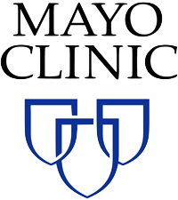



Questions or Concerns?

Email: mpnpilotapp@asu.edu

Phone: 602-827-2314

**The purpose of the study is to explore how educational resources and/or mobile applications can improve fatigue and symptom burden in MPN.**

**Have you been diagnosed with Myeloproliferative Neoplasm (MPN) cancer?**

***Seeking MPN cancer patients living in the United States and over the age of 18 to participate in an 8-week health intervention study!***

*Participation is Voluntary*

# To check eligibility, visit the link at:

[**http://bit.ly/mpnpilotapp**](http://bit.ly/mpnpilotapp)

**(case sensitive)**

**You will be asked to:**

* **Be willing to be randomized to one of four different groups that may include a combination of education materials and/or mobile health apps**
* **Use Fitbit device to track activity & sleep**
* **Complete questionnaires at baseline, mid-point, and post-intervention**

**Qualifying and enrolled participants will receive a FREE Fitbit device and can earn up to $50!**